1. Name each CRUD operation and it’s corresponding Http method.

Create: HttpPost

Read: HttpGet

Update: HttpPut

Delete: HttpDelete

1. Why do the Create and Update methods require a Book parameter and the other methods do not?

The Create and Update methods require a Book parameter because they insert book objects into our database.

1. Explain the purpose of the CreatedAtRoute method.

To return an Http Response and to return the URI of our new object

1. Do browser screen prints showing the data returned from the Get methods, with and without a book id.

Without Book id



With Book id

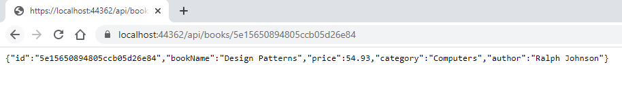

1. What was used to force the JSON field names to match the model class field names?

The .AddJsonOptions(options => options.UseMemberCasing) added on the AddMVC method call forces Json field names to match the model field names.

1. What was used to override a name derived from the model with a different JSON field name?

The JsonProperty attribute overrides the derived name from the Model.

1. Do a browser screen print verifying the new JSON property names.



1. Using Postman, do a screen print showing the JSON data returned from a Get request.

